Maven 購物車(Maven Shopping Cart)
環境Maven + Spring webmvc + hibernate
- 建立Maven webapp
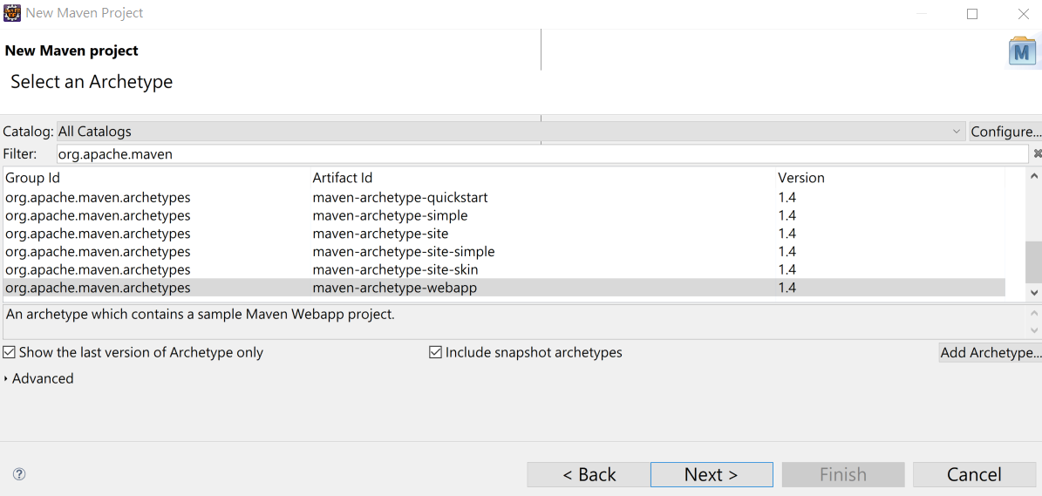
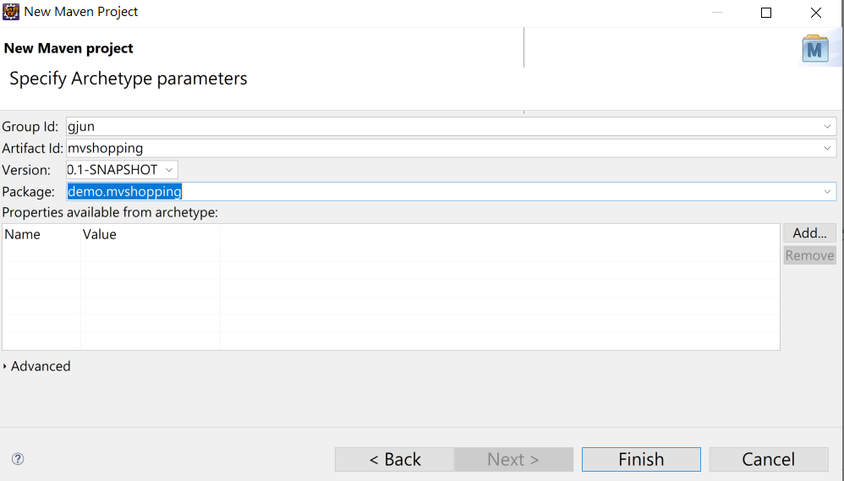
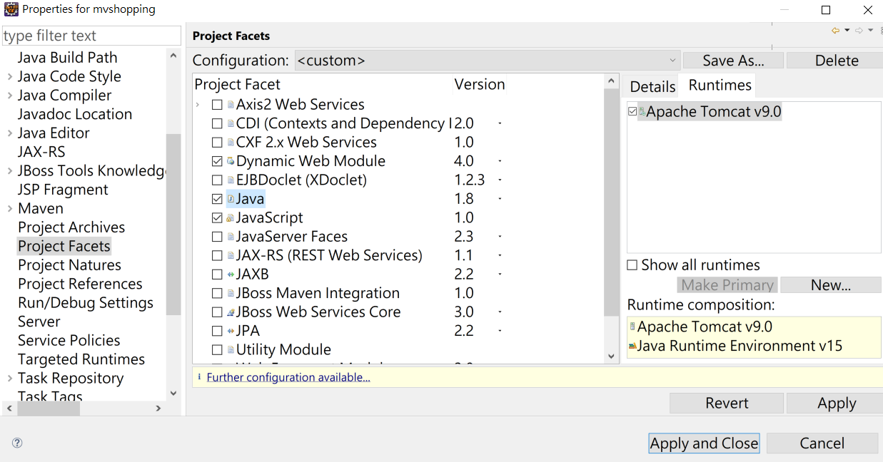
修改web.xml 為 4.0版本

<?xml version="1.0" encoding="UTF-8"?>
<web-app xmlns:xsi="http://www.w3.org/2001/XMLSchema-instance"
xmlns="http://xmlns.jcp.org/xml/ns/javaee" xsi:schemaLocation="http://xmlns.jcp.org/xml/ns/javaee http://xmlns.jcp.org/xml/ns/javaee/web-app_4_0.xsd" id="WebApp_ID" version="4.0">
<display-name>mvsusertable</display-name>
<welcome-file-list>
<welcome-file>index.html</welcome-file>
<welcome-file>index.htm</welcome-file>
<welcome-file>index.jsp</welcome-file>
<welcome-file>default.html</welcome-file>
<welcome-file>default.htm</welcome-file>
<welcome-file>default.jsp</welcome-file>
</welcome-file-list>
</web-app>
- Maven Dependences + Spring webmvc + Gson + Hibernate + Mysql Connector java +jstl

<dependency>
<groupId>javax.servlet</groupId>
<artifactId>jstl</artifactId>
<version>1.2</version>
</dependency>
<dependency>
<groupId>mysql</groupId>
<artifactId>mysql-connector-java</artifactId>
<version>8.0.22</version>
</dependency>
<dependency>
<groupId>org.springframework</groupId>
<artifactId>spring-webmvc</artifactId>
<version>5.2.17.RELEASE</version>
</dependency>
<dependency>
<groupId>org.hibernate</groupId>
<artifactId>hibernate-core</artifactId>
<version>5.5.7.Final</version>
</dependency>
<dependency>
<groupId>com.google.code.gson</groupId>
<artifactId>gson</artifactId>
<version>2.8.8</version>
</dependency>

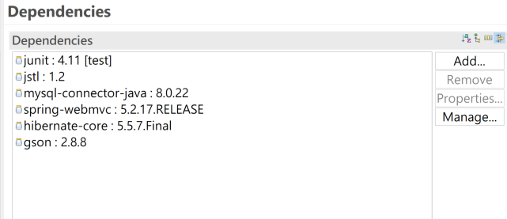
- Spring webmvc 作業環境:
web.xml加入

<servlet>
<servlet-name>dispatcher</servlet-name>
<servlet-class>org.springframework.web.servlet.DispatcherServlet
</servlet-class>
<load-on-startup>1</load-on-startup>
</servlet>
<servlet-mapping>
<servlet-name> dispatcher </servlet-name>
<url-pattern>/</url-pattern>
</servlet-mapping>

加入 dispatcher-servlet.xml
<?xml version='1.0' encoding='UTF-8' ?>
<beans xmlns="http://www.springframework.org/schema/beans"
xmlns:xsi="http://www.w3.org/2001/XMLSchema-instance"
xmlns:p="http://www.springframework.org/schema/p"
xmlns:aop="http://www.springframework.org/schema/aop"
xmlns:mvc="http://www.springframework.org/schema/mvc"
xmlns:context="http://www.springframework.org/schema/context"
xmlns:tx="http://www.springframework.org/schema/tx"
xsi:schemaLocation="http://www.springframework.org/schema/beans http://www.springframework.org/schema/beans/spring-beans-4.0.xsd
http://www.springframework.org/schema/aop http://www.springframework.org/schema/aop/spring-aop-4.0.xsd
http://www.springframework.org/schema/mvc
http://www.springframework.org/schema/mvc/spring-mvc-4.0.xsd
http://www.springframework.org/schema/context http://www.springframework.org/schema/context/spring-context-4.0.xsd
http://www.springframework.org/schema/tx http://www.springframework.org/schema/tx/spring-tx-4.0.xsd">
<mvc:annotation-driven />
<mvc:resources location="/images/" mapping="/images/**" />
<mvc:resources location="/js/" mapping="/js/**" />
<context:component-scan base-package="demo.controller"></context:component-scan>
<bean id="viewResolver"
class="org.springframework.web.servlet.view.InternalResourceViewResolver"
p:prefix="/WEB-INF/jsp/"
p:suffix=".jsp" />
</beans>
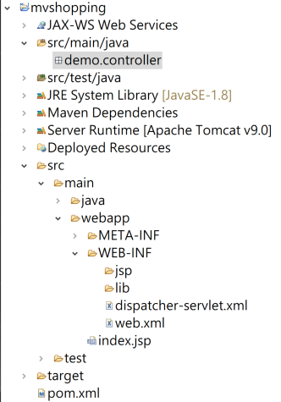
- 測試Spring webmvc:

import org.springframework.stereotype.Controller;
import org.springframework.ui.Model;
import org.springframework.web.bind.annotation.RequestMapping;
import org.springframework.web.bind.annotation.RequestMethod;
import org.springframework.web.bind.annotation.ResponseBody;

@Controller
public class HelloWorldController {

@RequestMapping(value = "/redirect", method = RequestMethod.GET)
public String authorInfo(Model model) {
return "redirect:/hello";
}

@RequestMapping("/hello")
public String hello(Model model) {
model.addAttribute("greeting", "Hello Spring MVC");
return"helloworld";
}

@RequestMapping(value = "/text" , produces="application/plain;charset=utf8")
@ResponseBody
public String authorInfo2(Model model) {
//model.addAttribute("info","ResponseBody Info");
return "ResponseBody";
}

}
<%@ page language="java" contentType="text/html; charset=UTF-8"
pageEncoding="UTF-8"%>
<!DOCTYPE html>
<html>
<head>
<meta http-equiv="Content-Type" content="text/html; charset=UTF-8">
<title>Spring4 MVC -HelloWorld</title>
</head>
<body>
<h1>${greeting}</h1>
</body>
</html>

- 建立購物車資料模型:
package model;
public class Product {
private String id;
private String name;
private String photo;
private double price;

public String getId() {
return id;
}

public void setId(String id) {
this.id = id;
}

public String getName() {
return name;
}

public void setName(String name) {
this.name = name;
}

public String getPhoto() {
return photo;
}

public void setPhoto(String photo) {
this.photo = photo;
}

public double getPrice() {
return price;
}

public void setPrice(double price) {
this.price = price;
}

public Product() {
}

public Product(String id, String name, String photo, double price) {
this.id = id;
this.name = name;
this.photo = photo;
this.price = price;
}

}
================================================================
package model;
public class Item {

private Product product;
private int quantity;

public Product getProduct() {
return product;
}

public void setProduct(Product product) {
this.product = product;
}

public int getQuantity() {
return quantity;
}

public void setQuantity(int quantity) {
this.quantity = quantity;
}

public Item() {
}

public Item(Product product, int quantity) {
this.product = product;
this.quantity = quantity;
}

}

package model;
import java.util.ArrayList;
import java.util.List;

public class ProductModel {

private List<Product> products;

public ProductModel() {
this.products = new ArrayList<Product>();
this.products.add(new Product("p01", "JBud Elite", "images/p1.jpg", 20));
this.products.add(new Product("p02", "EdiMax Wifi", "images/p2.jpg", 21));
this.products.add(new Product("p03", "Asus Laptop", "images/p3.jpg", 22));
}

public List<Product> findAll() {
return this.products;
}

public Product find(String id) {
for (Product product : this.products) {
if (product.getId().equalsIgnoreCase(id)) {
return product;
}
}
return null;
}

}
- 建立控制器 ProductCartController , CartController

package demo.controller;

import org.springframework.stereotype.Controller;
import org.springframework.ui.ModelMap;
import org.springframework.web.bind.annotation.RequestMapping;
import org.springframework.web.bind.annotation.RequestMethod;
import model.ProductModel;

@Controller
@RequestMapping(value = "/productcart")
public class ProductCartController {

@RequestMapping(method = RequestMethod.GET)
public String index(ModelMap modelMap) {
ProductModel productModel = new ProductModel();
modelMap.put("products", productModel.findAll());
return "index";
}

}

package demo.controller;

import java.util.ArrayList;
import java.util.List;
import javax.servlet.http.HttpSession;
import org.springframework.stereotype.Controller;
import org.springframework.web.bind.annotation.PathVariable;
import org.springframework.web.bind.annotation.RequestMapping;
import org.springframework.web.bind.annotation.RequestMethod;

import model.*;

@Controller
@RequestMapping(value = "/cart")
public class CartController {

@RequestMapping(value = "index", method = RequestMethod.GET)
public String index() {
return "cart/cartindex";
}

@RequestMapping(value = "buy/{id}", method = RequestMethod.GET)
public String buy(@PathVariable("id") String id, HttpSession session) {
ProductModel productModel = new ProductModel();
if (session.getAttribute("cart") == null) {
List<Item> cart = new ArrayList<Item>();
cart.add(new Item(productModel.find(id), 1));
session.setAttribute("cart", cart);
} else {
List<Item> cart = (List<Item>) session.getAttribute("cart");
int index = this.exists(id, cart);
if (index == -1) {
cart.add(new Item(productModel.find(id), 1));
} else {
int quantity = cart.get(index).getQuantity() + 1;
cart.get(index).setQuantity(quantity);
}
session.setAttribute("cart", cart);
}
return "redirect:/cart/index";
}

@RequestMapping(value = "remove/{id}", method = RequestMethod.GET)
public String remove(@PathVariable("id") String id, HttpSession session) {
ProductModel productModel = new ProductModel();
List<Item> cart = (List<Item>) session.getAttribute("cart");
int index = this.exists(id, cart);
cart.remove(index);
session.setAttribute("cart", cart);
return "redirect:/cart/index";
}

private int exists(String id, List<Item> cart) {
for (int i = 0; i < cart.size(); i++) {
if (cart.get(i).getProduct().getId().equalsIgnoreCase(id)) {
return i;
}
}
return -1;
}

}

- 檢視畫面 index.jsp , cartindex.jsp
<%@ page language="java" contentType="text/html; charset=UTF-8"
pageEncoding="UTF-8"%>
<%@ taglib prefix="c" uri="http://java.sun.com/jsp/jstl/core" %>
<html>
<head>
<meta http-equiv="Content-Type" content="text/html; charset=UTF-8">
<title>Product Page</title>
</head>
<body>

<h3>Products Page</h3>
<table cellpadding="2" cellspacing="2" border="1">
<tr>
<th>Id</th>
<th>Name</th>
<th>Photo</th>
<th>Price</th>
<th>Buy</th>
</tr>
<c:forEach var="product" items="${products }">
<tr>
<td>${product.id }</td>
<td>${product.name }</td>
<td><img src="${pageContext.request.contextPath }/${product.photo }" width="150"></td>
<td>${product.price }</td>
<td align="center">
<a href="${pageContext.request.contextPath }/cart/buy/${product.id}">Buy Now</a>
</td>
</tr>
</c:forEach>
</table>

</body>
</html>

<%@ page language="java" contentType="text/html; charset=UTF-8"
pageEncoding="UTF-8"%>
<%@ taglib prefix="c" uri="http://java.sun.com/jsp/jstl/core"%>
<html>
<head>
<meta http-equiv="Content-Type" content="text/html; charset=UTF-8">
<title>Cart Page</title>
</head>
<body>

<h3>Cart Page</h3>
<table cellpadding="2" cellspacing="2" border="1">
<tr>
<th>Option</th>
<th>Id</th>
<th>Name</th>
<th>Photo</th>
<th>Price</th>
<th>Quantity</th>
<th>Sub Total</th>
</tr>
<c:set var="total" value="0"></c:set>
<c:forEach var="item" items="${sessionScope.cart }">
<c:set var="total"
value="${total + item.product.price * item.quantity }"></c:set>
<tr>
<td align="center">
<a href="${pageContext.request.contextPath }/cart/remove/${item.product.id }"
onclick="return confirm('確定要刪除 ${item.product.name}?')">Remove</a></td>
<td>${item.product.id }</td>
<td>${item.product.name }</td>
<td><img src="${pageContext.request.contextPath }/${item.product.photo }"
width="150"></td>
<td>${item.product.price }</td>
<td>${item.quantity }</td>
<td>${item.product.price * item.quantity }</td>
</tr>
</c:forEach>
<tr>
<td colspan="6" align="right">Sum</td>
<td>${total }</td>
</tr>
</table>
<br>
<a href="${pageContext.request.contextPath }/productcart">Continue Shopping</a>

</body>
</html>
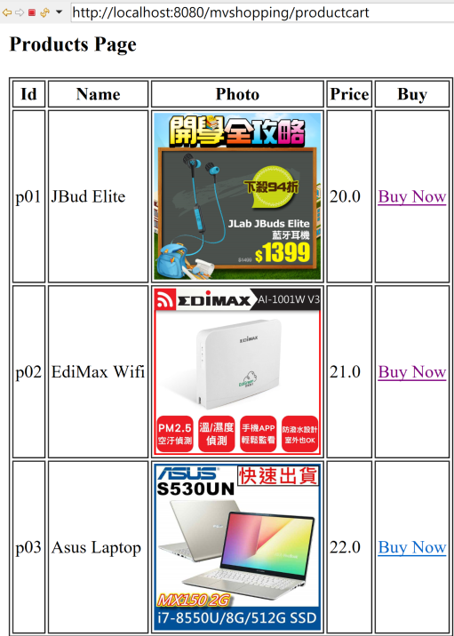
最後將model Product 資料建立MySQL Hibernate 連結
在src/main/java 建立 hibernate.cfg.xml
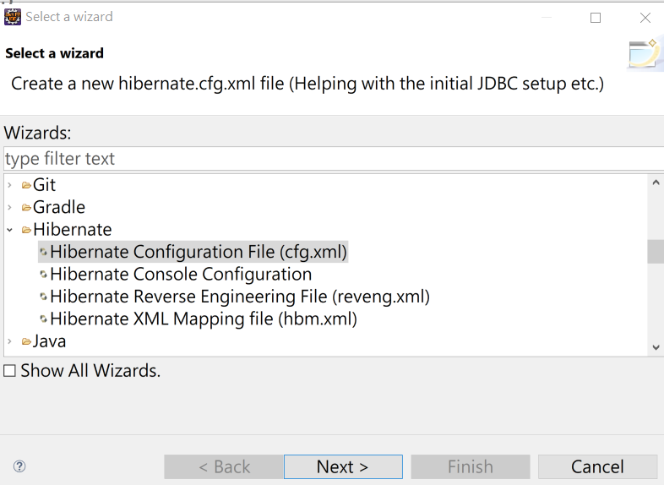
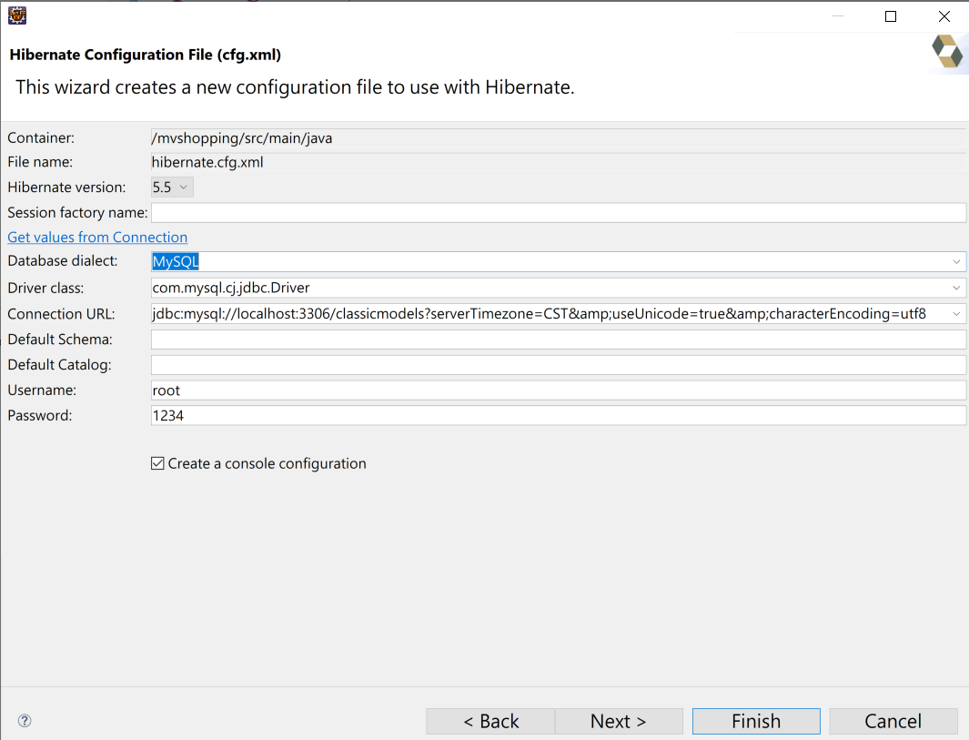

<?xml version="1.0" encoding="UTF-8"?>
<!DOCTYPE hibernate-configuration PUBLIC
"-//Hibernate/Hibernate Configuration DTD 3.0//EN"
"http://www.hibernate.org/dtd/hibernate-configuration-3.0.dtd">
<hibernate-configuration>
<session-factory>
<property name="hibernate.connection.driver_class">com.mysql.cj.jdbc.Driver</property>
<property name="hibernate.connection.password">1234</property>
<property name="hibernate.connection.url">jdbc:mysql://localhost:3306/classicmodels?serverTimezone=CST&amp;useUnicode=true&amp;characterEncoding=utf8</property>
<property name="hibernate.connection.username">root</property>
<property name="hibernate.dialect">org.hibernate.dialect.MySQLDialect</property>
</session-factory>
</hibernate-configuration>

建立資料庫表格 mvproduct

CREATE TABLE `classicmodels`.`mvproduct` (
`id` VARCHAR(10) NOT NULL,
`name` VARCHAR(80) NOT NULL,
`photo` VARCHAR(255) NOT NULL,
`price` DECIMAL(10,2) NOT NULL,
PRIMARY KEY (`id`))
ENGINE = InnoDB
DEFAULT CHARACTER SET = utf8;

INSERT INTO `classicmodels`.`mvproduct` (`id`, `name`, `photo`, `price`) VALUES ('p01', 'JBud Ear Phone', 'images/p1.jpg', '990.00');
INSERT INTO `classicmodels`.`mvproduct` (`id`, `name`, `photo`, `price`) VALUES ('p02', 'EDiMax Wifi', 'images/p2.jpg', '1200.00');
INSERT INTO `classicmodels`.`mvproduct` (`id`, `name`, `photo`, `price`) VALUES ('p03', 'ASUS Computer', 'images/p3.jpg', '25000.00');

修改 Entity class Product
package model;

import javax.persistence.Entity;
import javax.persistence.Id;
import javax.persistence.Table;

@Entity
@Table(name="mvproduct")
public class Product {
@Id
private String id;
private String name;
private String photo;
private double price;

public String getId() {
return id;
}

public void setId(String id) {
this.id = id;
}

public String getName() {
return name;
}

public void setName(String name) {
this.name = name;
}

public String getPhoto() {
return photo;
}

public void setPhoto(String photo) {
this.photo = photo;
}

public double getPrice() {
return price;
}

public void setPrice(double price) {
this.price = price;
}

public Product() {
}

public Product(String id, String name, String photo, double price) {
this.id = id;
this.name = name;
this.photo = photo;
this.price = price;
}

}
修改hibernate.cfg.xml maping Entity

<?xml version="1.0" encoding="UTF-8"?>
<!DOCTYPE hibernate-configuration PUBLIC "-//Hibernate/Hibernate Configuration DTD 3.0//EN"
"http://www.hibernate.org/dtd/hibernate-configuration-3.0.dtd">
<hibernate-configuration>
<session-factory>
<property name="hibernate.connection.driver_class">com.mysql.cj.jdbc.Driver</property>
<property name="hibernate.connection.password">1234</property>
<property name="hibernate.connection.url">jdbc:mysql://localhost:3306/classicmodels?serverTimezone=CST&amp;useUnicode=true&amp;characterEncoding=utf8</property>
<property name="hibernate.connection.username">root</property>
<property name="hibernate.dialect">org.hibernate.dialect.MySQLDialect</property>
<mapping class="model.Product"/>
</session-factory>
</hibernate-configuration>

最後修改ProductModel 執行程式:
public ProductModel() {
//this.products = new ArrayList<Product>();
//this.products.add(new Product("p01", "JBud Elite", "images/p1.jpg", 20));
//this.products.add(new Product("p02", "EdiMax Wifi", "images/p2.jpg", 21));
//this.products.add(new Product("p03", "Asus Laptop", "images/p3.jpg", 22));
from_mvDB();
}
void from_mvDB(){
Configuration configObj = new Configuration();
configObj.addAnnotatedClass(model.Product.class);
configObj.configure("hibernate.cfg.xml");
Session session = null;
session = configObj.buildSessionFactory().openSession();
Transaction tx = null;
try {
tx = session.beginTransaction();
products= session.createQuery("FROM Product").list();
System.out.println("product list :"+products);
tx.commit();
} catch (HibernateException e) {
if (tx != null)
tx.rollback();
e.printStackTrace();
} finally {
session.close();
}
}
修改為Spring Boot+ThymeLeaf 版本

- 修改Data JPA 資料庫:

application.properties
spring.datasource.url=jdbc:mysql://localhost/demo
spring.datasource.username=root
spring.datasource.password=1234
spring.datasource.driver-class-name=com.mysql.cj.jdbc.Driver

spring.jpa.show-sql=true
spring.jpa.properties.hibernate.format_sql=true

spring.jpa.properties.hibernate.hbm2ddl.auto=update

Product.java

import javax.persistence.*;

import lombok.AllArgsConstructor;
import lombok.Data;
import lombok.NoArgsConstructor;

@Entity
@Table(name="products")
@Data
@NoArgsConstructor
@AllArgsConstructor
public class Product {
@Id
Integer id;
String productname;
String description;
int price;
String path;
}

ProductRepository.java
import org.springframework.data.jpa.repository.JpaRepository;

public interface ProductRepository extends JpaRepository<Product,Integer> {

}

ProductController.java
import java.util.List;

import org.springframework.beans.factory.annotation.Autowired;
import org.springframework.web.bind.annotation.RequestMapping;
import org.springframework.web.bind.annotation.RequestMethod;
import org.springframework.web.bind.annotation.RestController;
import org.springframework.web.servlet.ModelAndView;

import com.example.demo.model.*;

@RestController
public class ProductController {

@Autowired
ProductRepository repository;

@RequestMapping(value="/products",method=RequestMethod.GET)
public ModelAndView getAllProducts(){
List<Product> data=null;
data=repository.findAll();
ModelAndView viewModel=new ModelAndView("productView");
viewModel.addObject("products", data);
return viewModel;
}

}

productView.html

<!DOCTYPE html>
<html xmlns:th="http://www.thymeleaf.org">
<head>
<meta charset="utf-8">
<title>Product View</title>
<link rel="stylesheet"
href="https://maxcdn.bootstrapcdn.com/bootstrap/4.5.0/css/bootstrap.min.css">
<script
src="https://ajax.googleapis.com/ajax/libs/jquery/3.5.1/jquery.min.js"></script>
<script
src="https://cdnjs.cloudflare.com/ajax/libs/popper.js/1.16.0/umd/popper.min.js"></script>
<script
src="https://maxcdn.bootstrapcdn.com/bootstrap/4.5.0/js/bootstrap.min.js"></script>
</head>
<body>
<div class="container">
<h1>Products</h1>
<div class="row">
<div class="col-md-3" th:each="product : ${products}">
<div class="card">
<img class="card-img-top" th:src="${product.path}" alt="Card image">
<div class="card-body">
<h4 class="card-title" th:text="${product.productname}">John Doe</h4>
<p class="card-text" th:text="${product.description}">Some example text.</p>
價格:<p class="card-text" th:text="${product.price}">price</p>
<a th:href="@{'cart/buy/'+${product.id}}" class="btn btn-primary">buy</a>
</div>
</div>
</div>
</div>

</div>
</body>
</html>

購物車產品項:
Item.java
public class Item {

private Product product;
private int quantity;

public Product getProduct() {
return product;
}

public void setProduct(Product product) {
this.product = product;
}

public int getQuantity() {
return quantity;
}

public void setQuantity(int quantity) {
this.quantity = quantity;
}

public Item() {
}

public Item(Product product, int quantity) {
this.product = product;
this.quantity = quantity;
}

}
購物車控制器:
import javax.servlet.http.HttpSession;
import org.springframework.beans.factory.annotation.Autowired;
import org.springframework.web.bind.annotation.PathVariable;
import org.springframework.web.bind.annotation.RequestMapping;
import org.springframework.web.bind.annotation.RequestMethod;
import org.springframework.web.bind.annotation.RestController;
import org.springframework.web.servlet.ModelAndView;

import com.example.demo.model.*;
import java.util.*;

@RestController
@RequestMapping(value = "/cart")
public class CartController {
@Autowired
ProductRepository repository;

@RequestMapping(value = "/buy/{id}", method = RequestMethod.GET)
public ModelAndView buy(@PathVariable("id") Integer id, HttpSession session) {
List<Item> cart=null;

if (session.getAttribute("cart") == null) {
cart = new ArrayList<Item>();
Product p=repository.findById(id).get();
cart.add(new Item(p, 1));
session.setAttribute("cart", cart);
} else {
cart = (List<Item>) session.getAttribute("cart");
int index = this.exists(id, cart);
if (index == -1) {
Product p=repository.findById(id).get();
cart.add(new Item(p, 1));
} else {
int quantity = cart.get(index).getQuantity() + 1;
cart.get(index).setQuantity(quantity);
}
session.setAttribute("cart", cart);
}
ModelAndView mv=new ModelAndView("cart");
mv.addObject("cart", cart);
return mv;
}
private int exists(Integer id, List<Item> cart) {
for (int i = 0; i < cart.size(); i++) {
if (cart.get(i).getProduct().getId()==id) {
return i;
}
}
return -1;
}
}

cart.html
<html>
<head>
<html xmlns:th="http://www.thymeleaf.org">
<meta charset="UTF-8">
<title>Cart Page</title>
<link rel="stylesheet"
href="https://maxcdn.bootstrapcdn.com/bootstrap/4.5.0/css/bootstrap.min.css">
<script
src="https://ajax.googleapis.com/ajax/libs/jquery/3.5.1/jquery.min.js"></script>
<script
src="https://cdnjs.cloudflare.com/ajax/libs/popper.js/1.16.0/umd/popper.min.js"></script>
<script
src="https://maxcdn.bootstrapcdn.com/bootstrap/4.5.0/js/bootstrap.min.js"></script>

</head>
<body>
<div class="container">
<h2>Cart Page</h2>
<a href="/products">Continue Shopping</a>
<div class="row">
<table class="table table-light table-hover" border="1">
<tr class="table table-danger">
<th>Id</th>
<th>Name</th>
<th>Photo</th>
<th>Price</th>
<th>Qty</th>
</tr>
<tr th:each="item : ${cart}">
<td th:text="${item.product.id }"></td>
<td th:text="${item.product.productname }"></td>
<td><img th:src="@{'/'+${item.product.path}}" width="150"></td>
<td th:text="${item.product.price }"></td>
<td th:text="${item.quantity }"></td>
</tr>

</table>
</div>
</div>
</body>
</html>

